**How to run the program:**

**Step 1: Preparations**

**(You only have to do these steps once)**

1. Install **python** on your computer. If you don’t have administrator rights to add python to PATH, then install it through **Microsoft Store** rather than downloading from the official website (or ask IT to provide you admin privileges).

Let’s check if the python is installed correctly; open up terminal by hitting the Windows key and searching **cmd**:

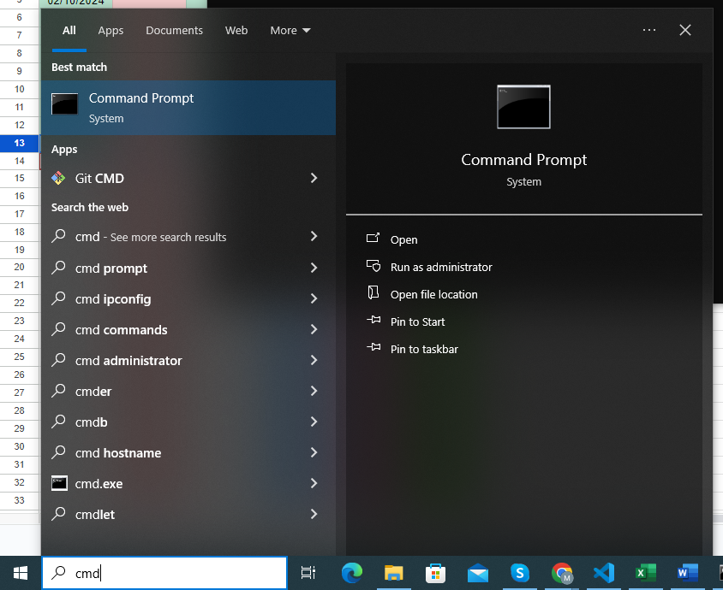

Type in **python –version** and hit enter. You should get a similar response:

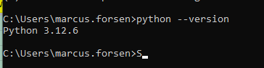

Version is not that important, as long as it’s the python 3.6+. Usually the latest version will do the job.

1. After python is installed, open up a terminal once again and install the required libraries. These libraries are: **pandas** and **openpyxl**. You can install libraries this way: **pip install pandas openpyxl.**



Then hit enter to install the libraries.

1. Now we need a text editor or an IDE to run the file. We will use **VSCode** for demonstration purposes. Install if through Microsoft Store just to make sure.

When you install it run the program and go to **Extensions** tab. Type in **python** and install the official python extension by Microsoft:

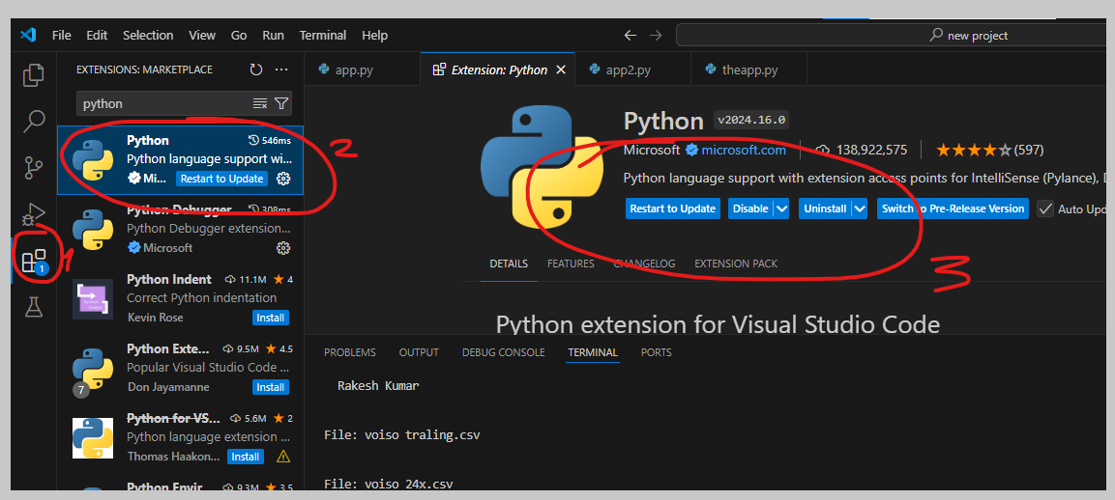

You need this extension to run the program unless you already know what you are doing. Sometimes extensions won’t show up because of some error. Uninstall the program and try to install it from a different source (for example if you have downloaded it from Microsoft Store, uninstall it and try to download it from Google).

If nothing works you can always try **pycharm**, another popular program for running python apps but it’s a bit resource heavy so I don’t recommend it as the first choice.

**Step 2: Downloading the Files**

Now, you have to do these steps daily, installing python and vscode was a one time thing.

1. Download the **voiso**, **coperato** and **voicespin** files (contact IT if you don’t know have an account or don’t know how to).
   1. For **voiso traling, voiso summitlife and voiso 24x**, always choose the previous and the next day and choose the time range between **07:00 and 02:00**. (At the time of writing this readme, the night shift was abandoned, so you can simply choose the same day and between 00:00 – 23:59. It’s up to you.)

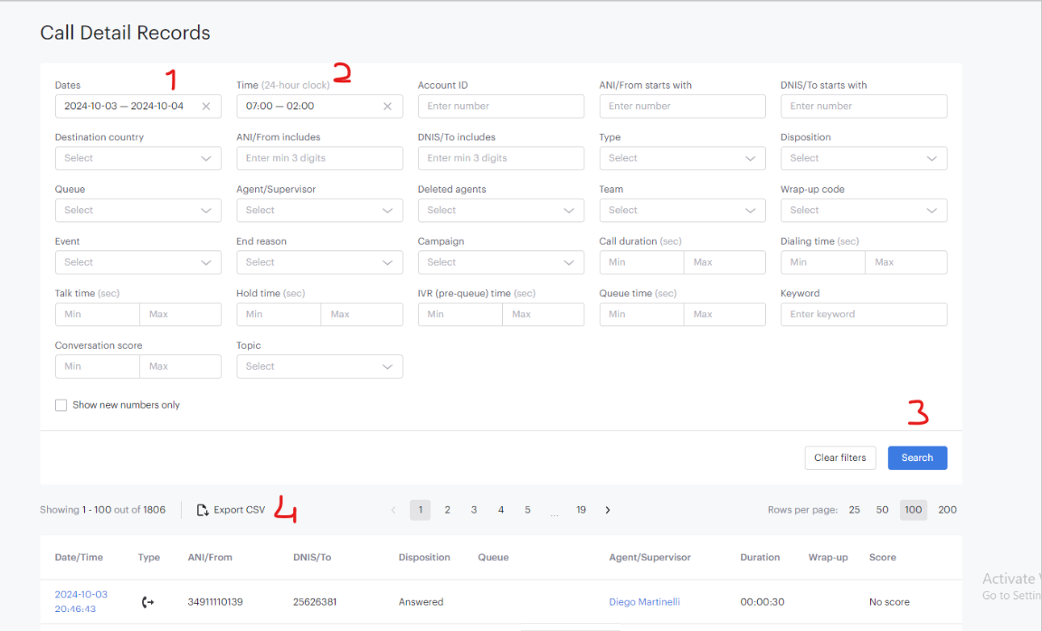

**Step 1**: Select Date. Today is 4th of October, Friday. So I will choose yesterday’s date (03.10) and today’s (04.10).  
**Step 2**: Select the time range. You can start 1 hour earlier and end 1 hour later just to make sure. I usually pick 07:00 and 02:00.

**Step 3**: Click on the Search button.  
**Step 4**: Export CSV and save as `**voiso traling**` (without quotes).

**Step 5**: Repeat the same steps for voiso summitlife and voiso 24x. Save them as **voiso summitlife** and **voiso 24x**.

* 1. For **coperato traling, coperato Signix and coperato 24x** things get a bit tricky. Choose the “**Calls History**” tab first, then choose the time range between **00:00 and 23:59** for the same day.

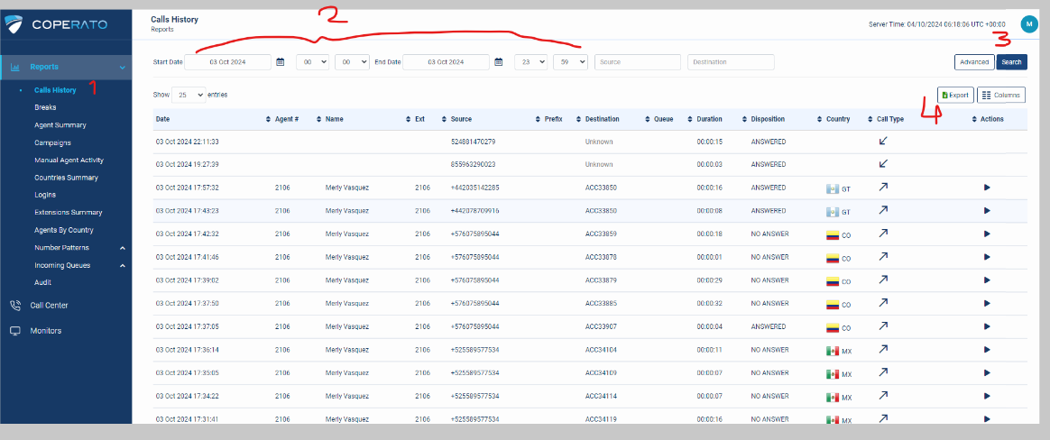

Save this file as **coperato traling2**. Yes, there is a 2 at the end because we are going to download 2 files from the coperato interface. Now click on the **Agent Summary** tab and repeat the process.  
  
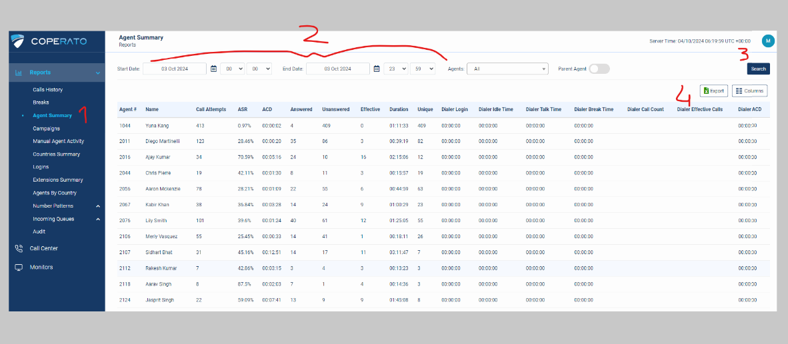

Now save this file as **coperato traling**. Yep, just that. What’s the difference? **Calls History** tab has detailed calls that our program uses to calculate the duration while the **Agent Summary** tab has the unique call count we need. Don’t worry about the details for now, I will explain them later but it’s not necessary unless you are interested in expanding the program.

Repeat the same process for coperato signix and coperato 24x. Save them as **coperato signix2** and **coperato signix**,then the coeprato 24x as; **coperato 24x2** and **coperato 24x.**

**Reminder**: Once again, don’t forget that Call history tab is the one with 2 at the end of the file name (**coperato traling2**) and Agent Summary tab is the normal one (**coperato traling**)

* 1. For **Voicespin**, it’s pretty much straightforward: Select date -> search and export. There is only one voicespin, no traling or 24x version etc. Just one.

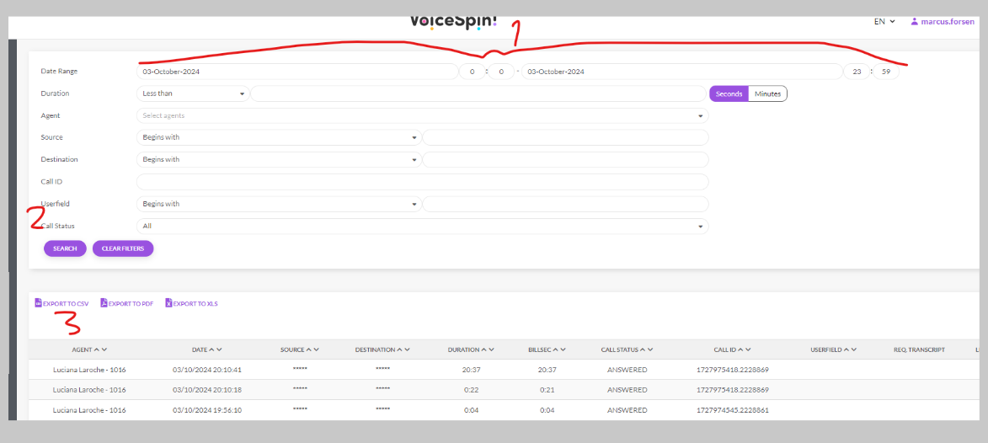

Save the file as **voicespin**

1. Now, one thing you must keep in mind at all times is the **agents.csv** file. It needs to be updated every time an agent has joined or was removed. Simply delete the row if the agent is gone, or add the new agent at the bottom (order doesn’t matter).

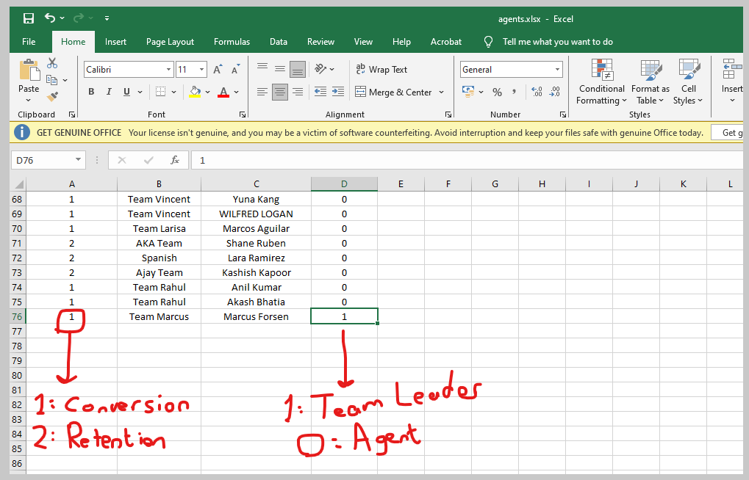

1. Copy and paste the files we have downloaded to the program’s main folder. Replace all if prompted. You should have a similar picture:

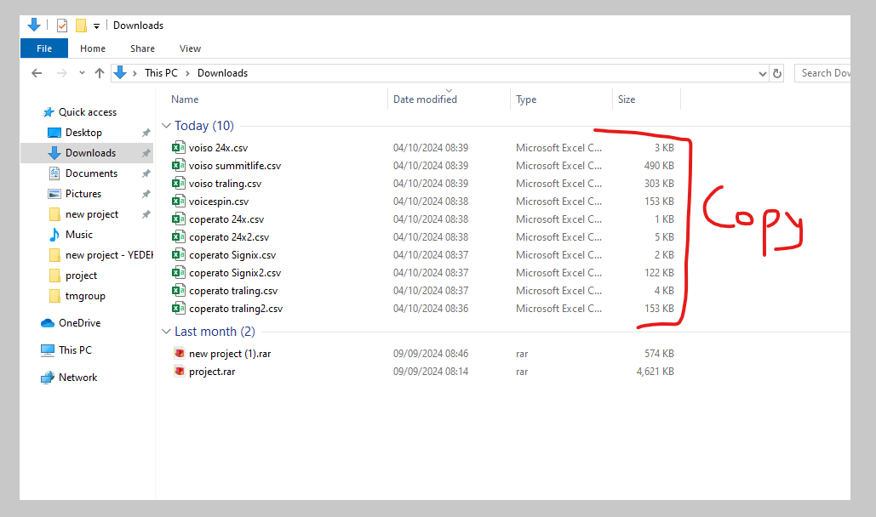

Then paste in here:

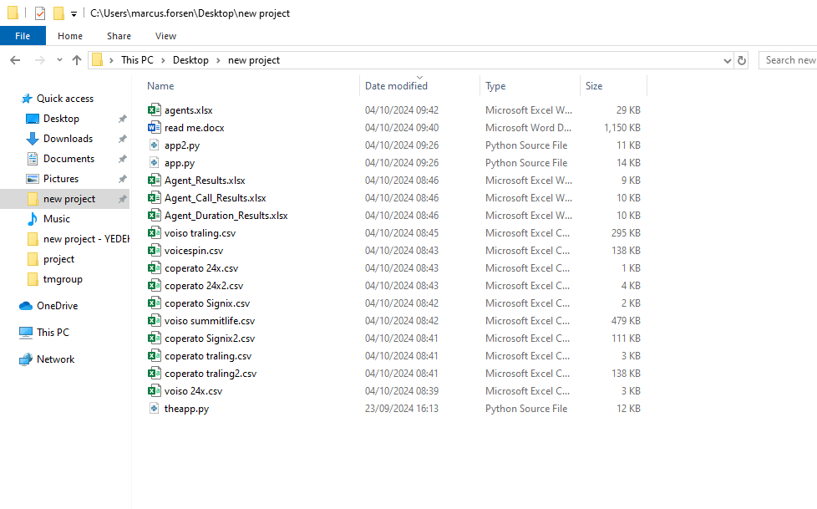

If any of the files have no data (only columns) then you must enter a dummy data. Don’t worry it won’t show up in the report since our call report doesn’t include any name/agent that’s not in the **agent.xlsx**.

Sometimes coperato 24x or voiso 24x will be empty. Just enter random name and numbers, it won’t matter.

**Step 3: Running the program**

1. Now let’s run the program, starting with **app.py**. Run VSCode and from Files tab, select Open Folder and select the program’s folder. For example it’s called new project on my Desktop.

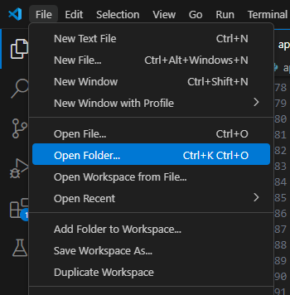

1. Don’t forget that the path needs to be updated if you are not using Marcus’ computer.

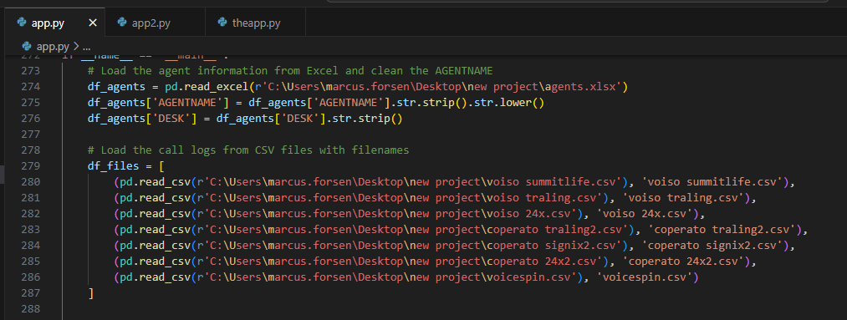

As you can see in this picture, the path of the files are in the desktop and new prpject folder:

“C:\Users\marcus.forsen\Desktop\new project\”

Let’s say you are not using my computer and your stage name is Daniel. Then you need to update these path lines like this:

“C:\Users\daniel.cole\Desktop\new project\”

Or instead of new project, you named the folder old project (Why would you do that). Just edit these parts in ALL of the apps (**app.py, app2.py** and **theapp.py**)

Hey, don’t forget to change the path of **agents.xlsx** as well**.**

1. Run the first app (**app.py**) by clicking on the Play button:

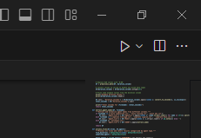

You should get similar feedback:

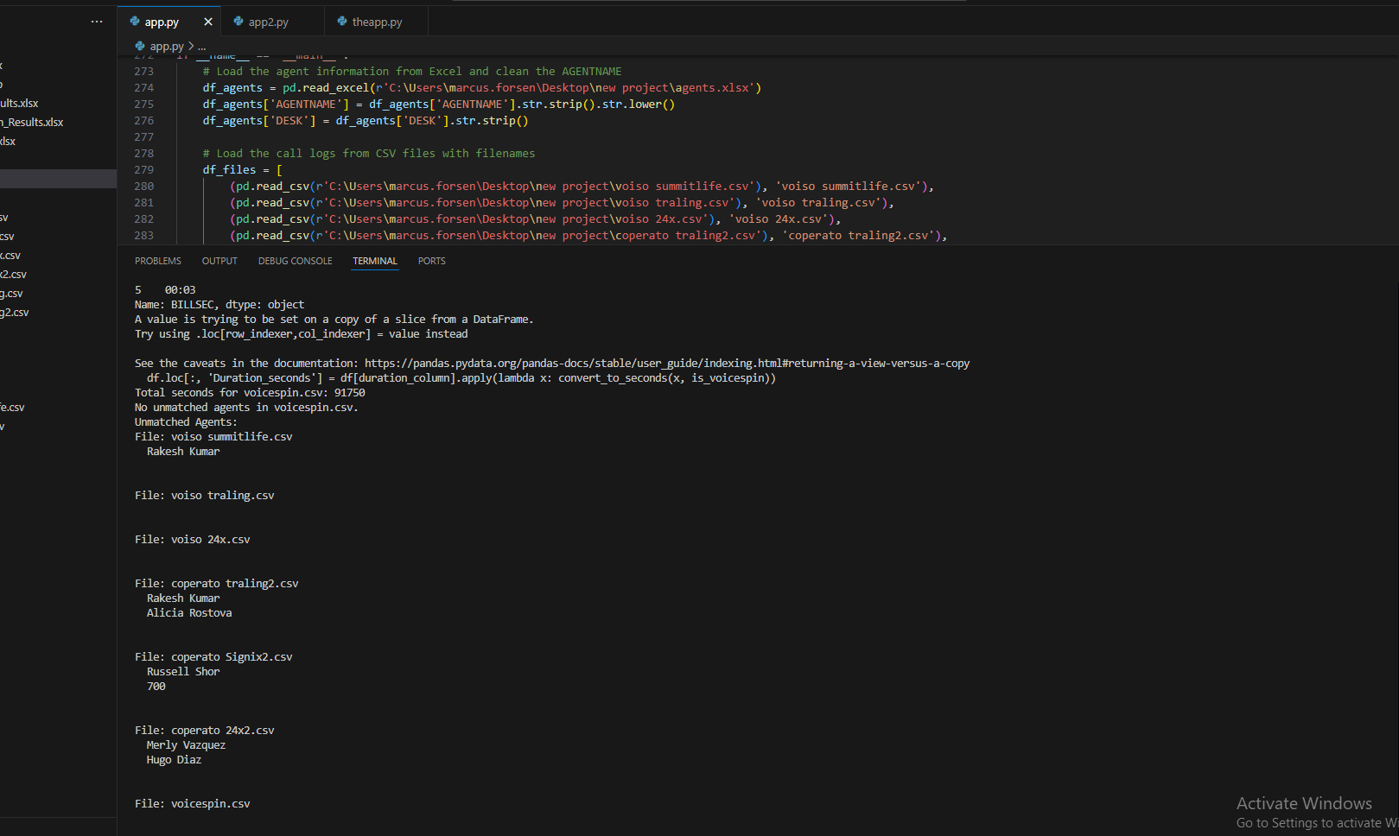

You will see some nonsense, but at the end you will get file names and names of the **unmatched agents**. The names you see under the files are either:

1. New agents who haven’t been added to the **agents.xlsx** file.
2. Old agents who left and you removed them from the **agents.xlsx**.
3. Agents whose names are written incorrectly. For example Christan instead of Christian. Or Merly Vazquez instead of Merly Vasquez.
4. Or the non-agent callers (support team etc.)

Now for the incorrect names, you either fix them in the coperato/voiso/voicespin files or you edit the name in your **agents.xlsx.** This is a choice you have to make, and there is no good answer to this (you will get why as you keep running the program). I personally advice you to don’t touch your main **agents.xlsx** file and instead fix those names in the call history files (voiso, traling, voicespin etc.)

Fix those names and re-run the program. You should get no unmatched agents (or only the support team)

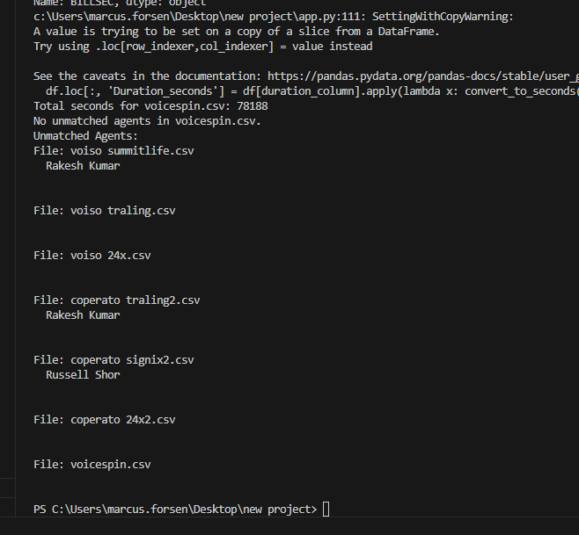

Looks good to me. No unmatched agents, except a few support or QC callers (we can ignore them).

1. Now let’s run the **app2.py**.

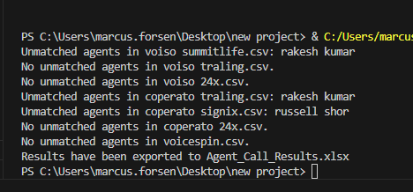

Repeat the same data cleaning/fixing steps if necessary.

1. Now let’s run our final app, **theapp.py** (yes, very creative)

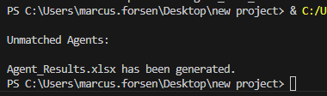

Now technically, it’s done. Check your folder, there should be 3 new files:

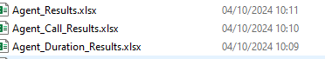

Ignore the Agent Call Result and Agent Duration Results, those are for the people who want more details (so if an agent claims the numbers are wrong, refer to those 2 result files first, it will tell you how many hours came from which file, or how many unique calls came from which file etc.)

Agent_Results.xlsx is the one you want (if you don’t see file extensions like .xlsx, google it on how to turn them on).

Now it’s up to you how you wanna style it. I personally copy paste all the data in our Agent_Results.xlsx and paste it in my Google Sheet and then replace it

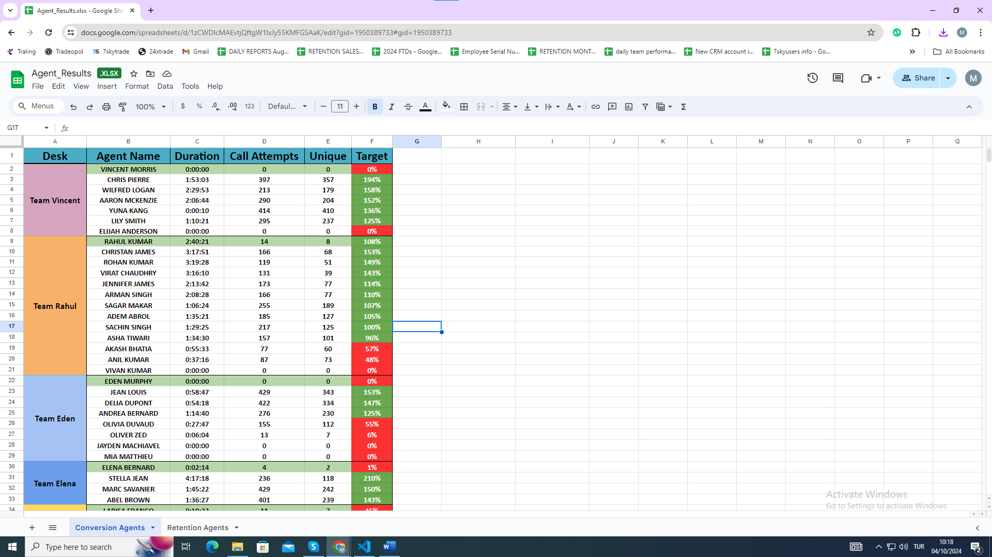

Now Copy paste:

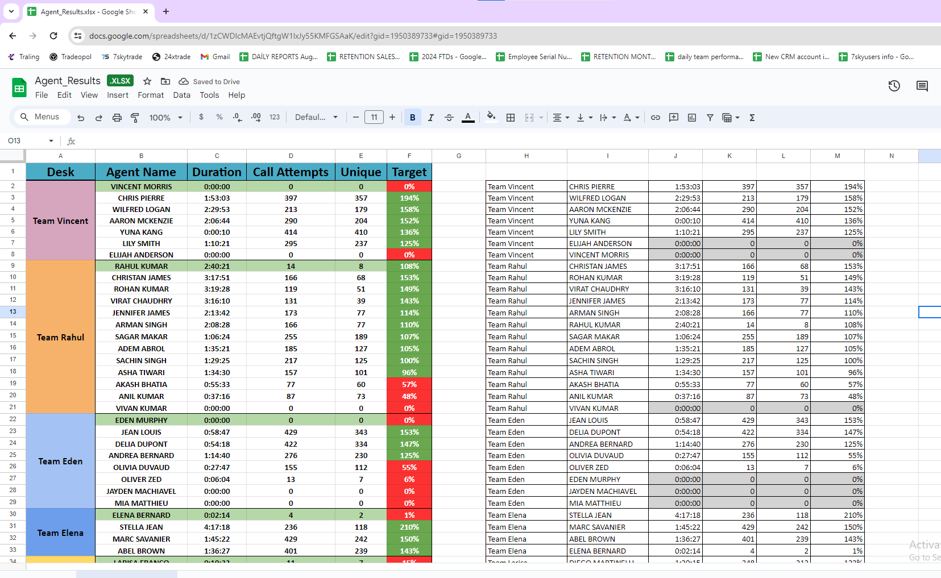

Then replace the data (use paint format etc.)

Or style it on your own way.

Congratulations. You are a certified Data Analyst. Now go see your manager and ask for a raise!

There is a copy on github. I keep it updated all times. Get it from there if you have lost some of the files.

<https://github.com/marcusforsen/tmgroup>

Note: the repo is public but I doubt people have any idea what that means, so for now we gonna just ignore it.